Why HANA Cloud is the best DB for business AI
- Core Role in SAP Application Stack
- HANA Cloud is central to all SAP applications where agents operate on top of business data.
- Supports every application scenario with a unified data foundation via multi-modeling data processing, advanced analytics, powerful data integration
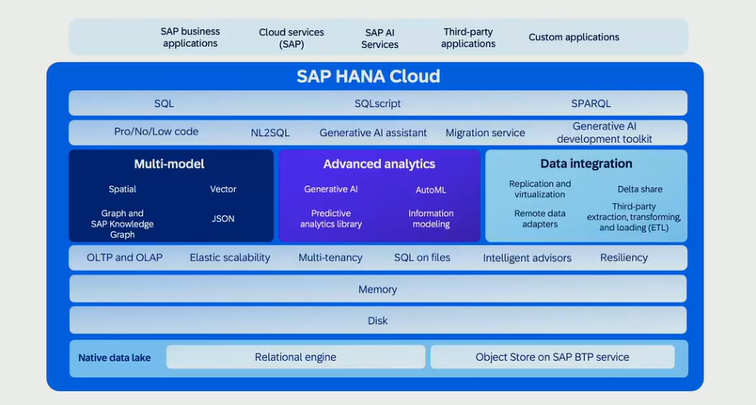
Breadth of Capabilities:
Multi-model Data Processing - Handles multiple data types and models in one system.
Advanced Analytics - Enables complex analysis and forecasting directly in the database.
Powerful Data Integration - Ensures data is combined, loaded, and prepared seamlessly.
Single Unified Platform - All capabilities run on an in-memory architecture within HANA Cloud.
Supports elastic scaling and cloud-native services.

Using AI with HANA Cloud
- Intelligent Assistance - Initial AI-powered help features introduced earlier in HANA Cloud.
- Joule Integration
- Integrated into HANA Cloud Central last year.
- Integrated into Build Code for developer workflows.
- Offers summarization of issues and system-health insights.
- Supports DB developers and data scientists.
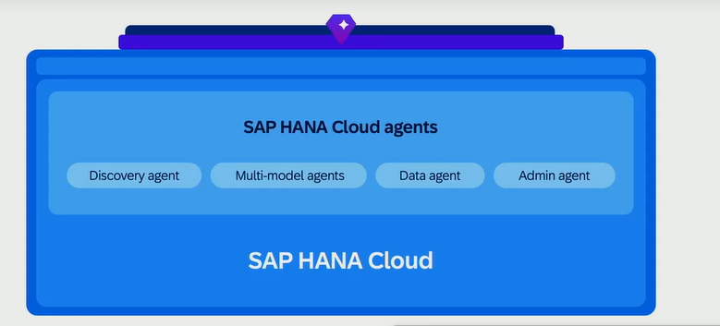
Holistic AI-Driven Understanding
Agents collaboratively interpret : System status, Available data, Best models for optimization, Insights for analysis
Simple Unified Interface : All delivered through the HANA Cloud Agents UI.
Functional Benefits : Automate DB administration, Extract insights from models, Build ML scenarios, Identify correct data for each use case

Knowledge Graph Extensions - Q1 this year
- Custom Knowledge Graph (KG) - Allows customers to build their own KG on top of existing data.
- Exposure to Joule - KG can be directly consumed by Joule for AI-driven reasoning.
- Agent Workflows
- Discovery Agent → maps artifacts in the KG
- Data Agent → runs queries based on KG context
- Prediction Insights via agent navigation of the KG
- Developer Experience - Developers can become AI developers without manually working with AI models.

Knowledge Graph Extensions - Q1 this year
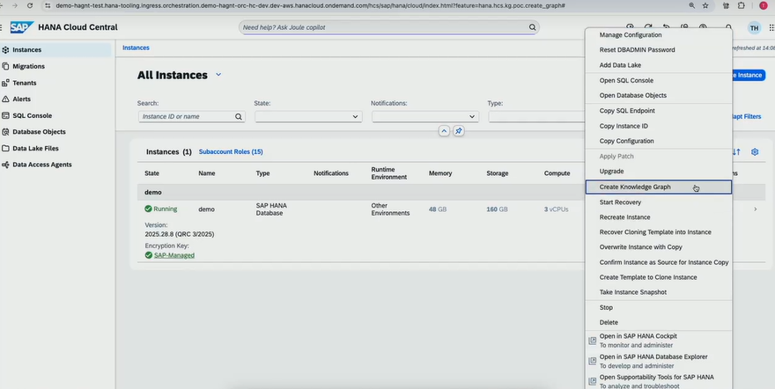
Knowledge Graph Extensions - Q1 this year
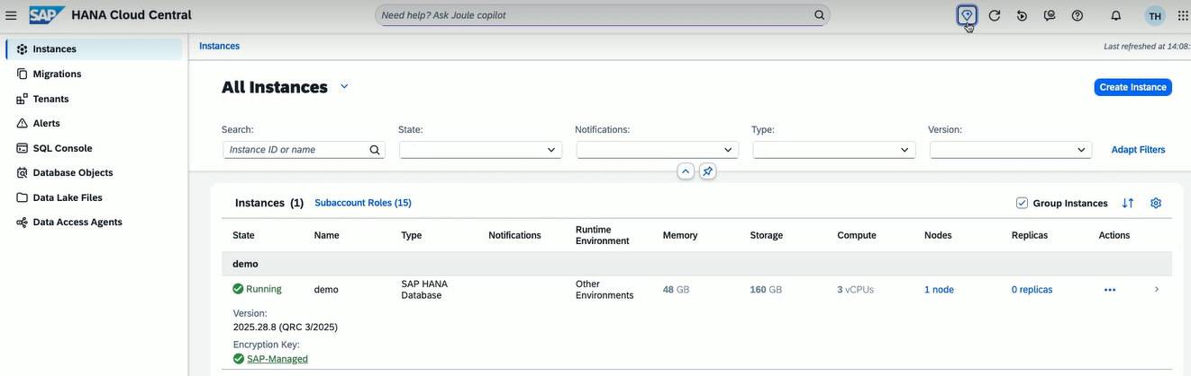
Knowledge Graph Extensions - Q1 this year
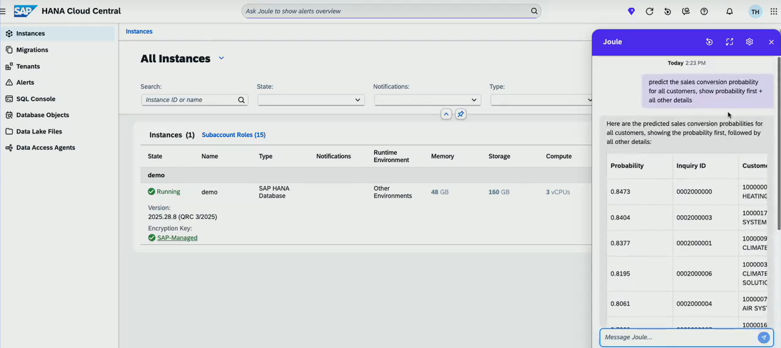
Cross-Product Access – MCP
- Cross-Product Access - Agents Beyond Joule
- Ability for tools like Copilot via MCP to integrate HANA Agents.
- MCP can pull agents and embed them into its own applications.
- Service Exposure for Joule - Local DB artifacts aren’t automatically visible to Joule.
- Developers must create exposed services or tools/agents for Joule consumption.
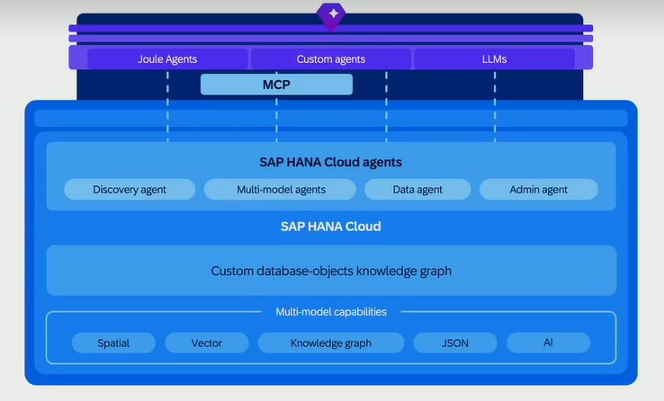
Database Administration with Admin agent
- Native Storage Advisor - Suggests which tables/columns stay hot vs warm
- SQL Plan Advisor - Recommends best execution plans
- Partition & Index Advisor - Optimizes performance through structural recommendations
- Elasticity Advisor - Identifies and manages workloads efficiently
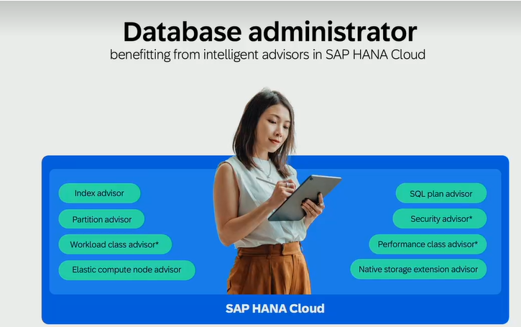
Traditional DBA Activities (Manual):
Install, configure, and provision databases, Perform backups and recovery, Apply patches and upgrades, Monitor and tune performance.
With Cloud (Automated):
One-click or API-based provisioning, Automated backups, Elastic scaling, Managed patches and upgrades, Heavy operational lifting removed.
Focused Administrative Agent - Reads system context
Chooses and executes the right advisor/tool
Provides holistic recommendations (performance, cost, reliability)
Holistic AI-Assisted Orchestrator - Natural language interaction with DB
Decisions made by triggering correct agent actions
Gives human-readable explanations
Executes safe reversible steps while keeping DBA informed
Enhances DBA capability — does not replace them
Joule Integration for DB Admin:
Start via HANA Cloud Central → Launch Joule
Joule explains what the admin agent can do
Enables conversational, guided administration
Custom Knowledge Graph Creation - Q1 This Year
- Ability to build KG on top of all data artifacts.
- HANA agents will use this KG within Joule to provide predictions and insights
Agentic memory – Planned for 2026
- Hyper-personalized conversations based on system history
- Consolidated knowledge used for proactive recommendations

